Introduction to Azure IoT

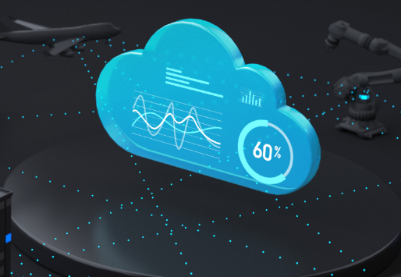

Azure is cloud services

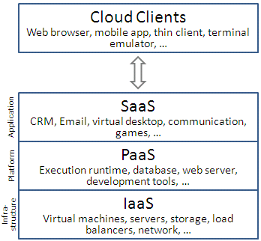

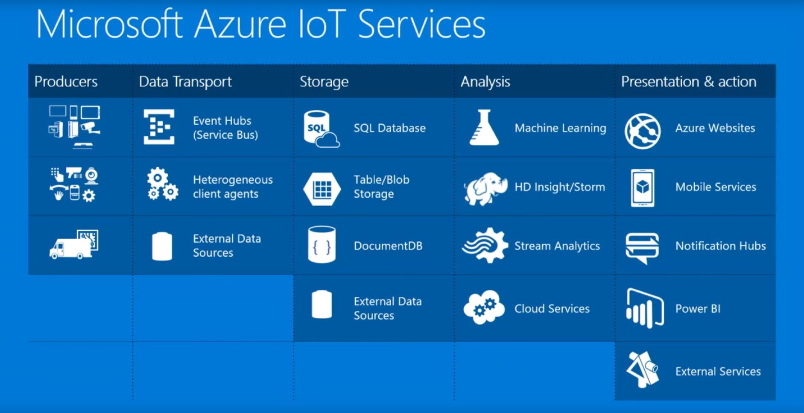

Azure IoT Services

* Azure IoT Central
* Azure IoT Solution Accelerators
* Azure IoT Edge
* Azure IoT Hub

Azure IoT Central

Create IoT deployments faster and more easily with fully managed software as a solution (SaaS) for enterprise IoT.

Azure IoT Solution Accelerators

Build customized IoT solutions for any industry vertical by using common use case templates with proven results.

Azure IoT Edge

Create better experiences by moving workloads from the cloud to edge devices.

Azure IoT Hub

Connect, manage, and scale billions of IoT devices from the edge to the cloud.

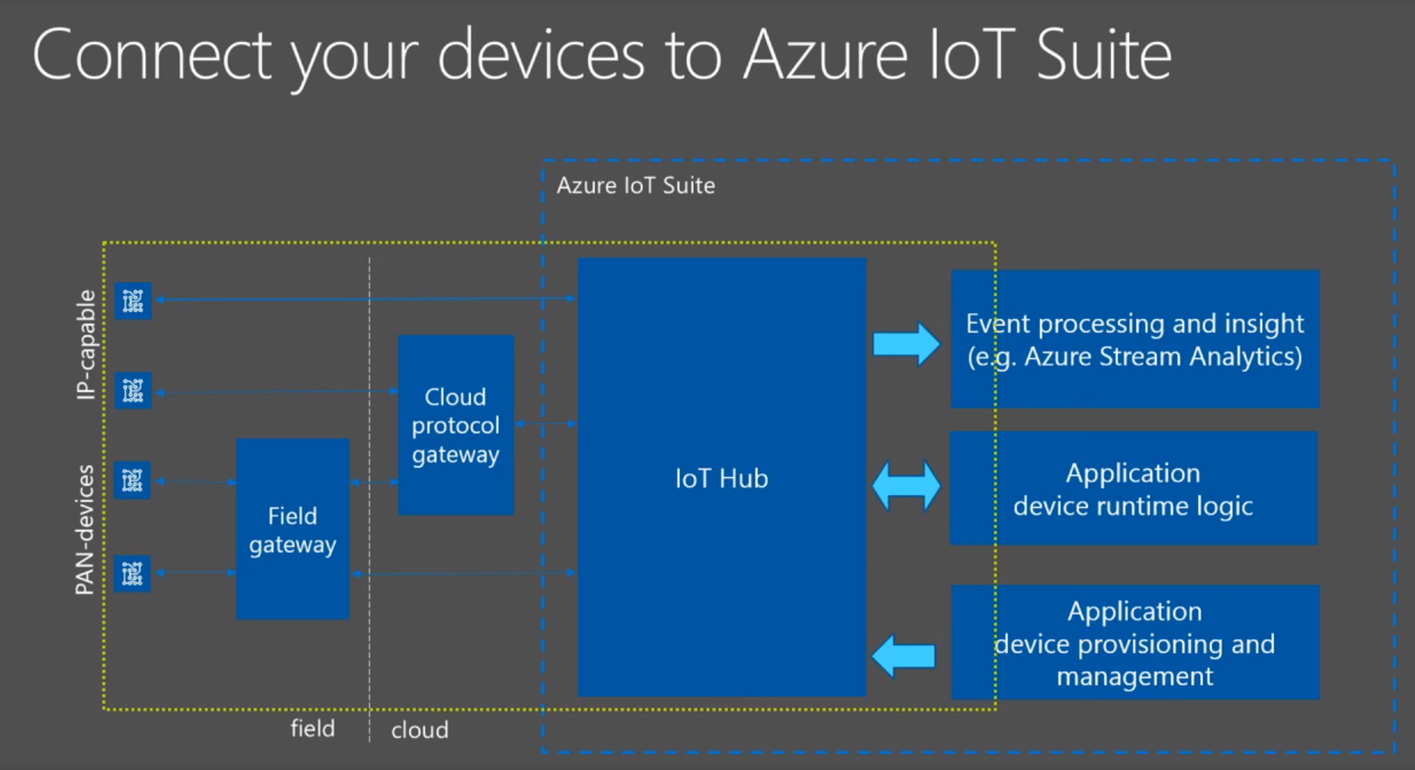

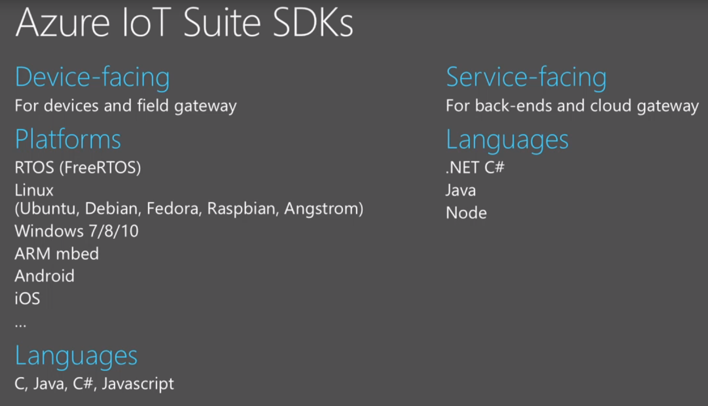

Azure Certified for IoT device catalog

https://catalog.azureiotsolutions.com

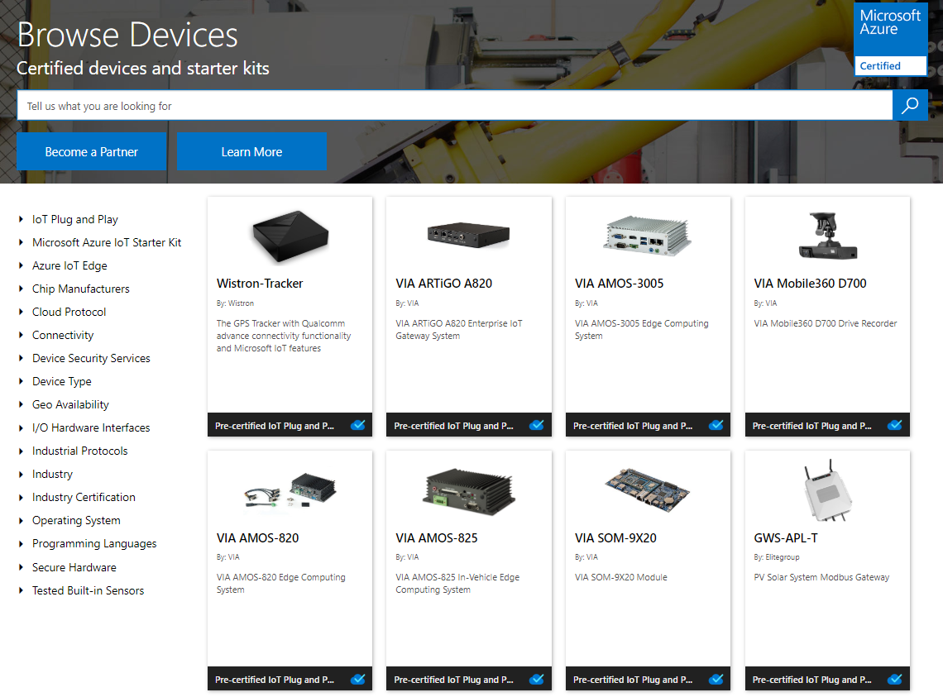

What's next?

